**Department of Electrical Engineering**

|  |  |
| --- | --- |
| **Faculty Member: Dr. Huma Ghafoor** | **Dated: 16/02/2023** |
|  |  |
| **Course/Section: BEE 12** | **Semester: Spring 2023** |
|  |  |

**EE-351 Communication Systems**

# Lab3: AM Transmission, Amplitude Modulation

|  |  |  |  |  |  |  |
| --- | --- | --- | --- | --- | --- | --- |
| **Name** | **Reg. No** | **Viva / Quiz / Lab Performance** | **Teamwork** | **Ethics** | **Software tool Usage** | **Analysis of data in Lab Report** |
|  |  | **5 Marks** | **5 Marks** | **5 Marks** | **5 Marks** | **5 Marks** |
| **Hassan Rizwan** | **335753** |  |  |  |  |  |
| **M. Ahmed Mohsin** | **333060** |  |  |  |  |  |
| **Syeda Fatima Zahra** | **334379** |  |  |  |  |  |
| **Amina Bashir** | **343489** |  |  |  |  |  |

**Lab 3: AM TRANSMISSION, AMPLITUDE MODULATION**

**Objectives**

Our learning objective for this lab is to get ourselves familiarized with transmission in communication system and to go through different circuit parts. First, we will modulate the signal and go through the calculation of their modulation indexes, waveforms. Then we will learn the RF power amplifier applications and its role in transmission.

Introduction:

In this lab we used the balanced modulator to generate AM signal and examine its modulation index, envelope form, and other features.

**Amplitude Modulation:**

* In AM, carrier doesn't vary in amplitude
* Modulating data consists of frequencies higher or lower than carrier
* Signal components are sidebands, responsible for variations in overall amplitude
* Amplitude modulator shifts frequency of message signal to that of carrier
* Resulting envelope on modulated signal is copy of message signal
* Waveform of envelope matches with carrier signal.

**Modulation Index:**

* Modulation index quantifies peaks in AM signal
* It's ratio of message signal amplitude to carrier signal amplitude
* Formula: **m = (A-B)/(A+B)**
* To get percentage, multiply by 100
* Too much variation in message signal can result in trapezoid AM signal
* Voice signals often have such variations, making it hard to determine index from envelope

**Transmission Efficiency:**

* Sideband power ratio is the ratio of power in sidebands to total power
* Formula: **P(sidebands) / P(total)**

**Lab 3: Lab Tasks**

1. Locate a AM/SSB transmitter and VCO-LO circuit block and connect the circuit as shown in figure 2-6.Be sure to place a two-post connector at the place of 1000kHz on the VCO-LO circuit block. Set switched S1, S2 and S3 to off.

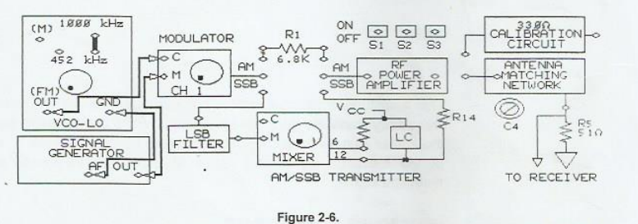

1. Connect the oscilloscope channel 1 to message signal input(M) of the modulator. While observing the signal on channel 1, adjust signal generator to 0.2Vpk-pk, 2Khz sine wave signal at M.

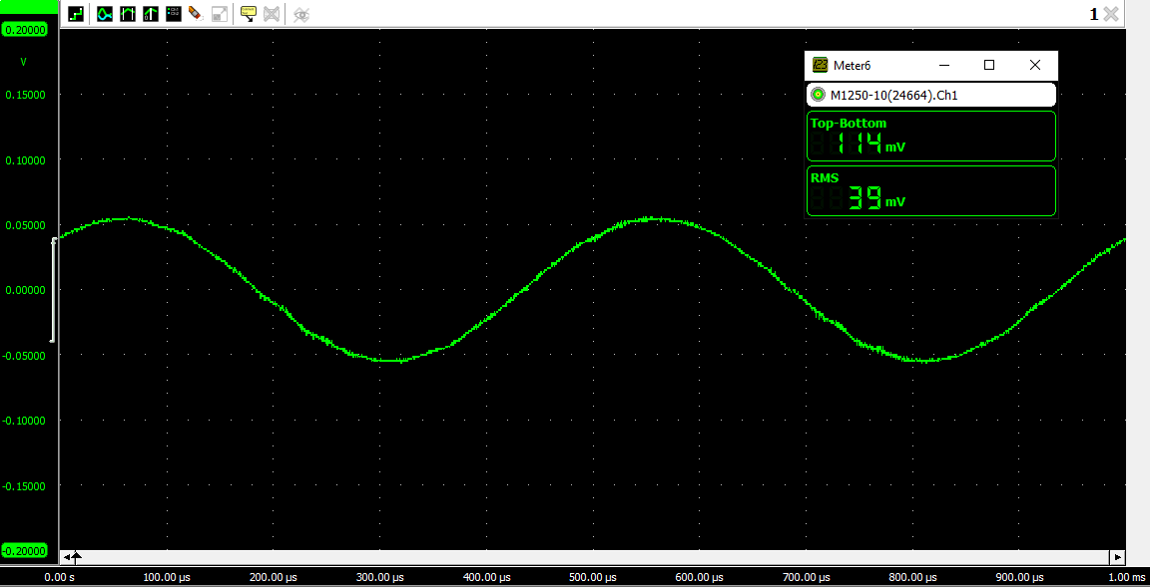

1. Connect the channel 2 probe to carrier signal input(C) of the modulator, while observing the signal on channel 2, adjust VCO-LO for 0.2Vpk-pk, 1000 kHz signal at C. Adjust the carrier frequency with negative supply knob on the base unit and adjust the carrier amplitude with knob on the VCO-LO circuit block.

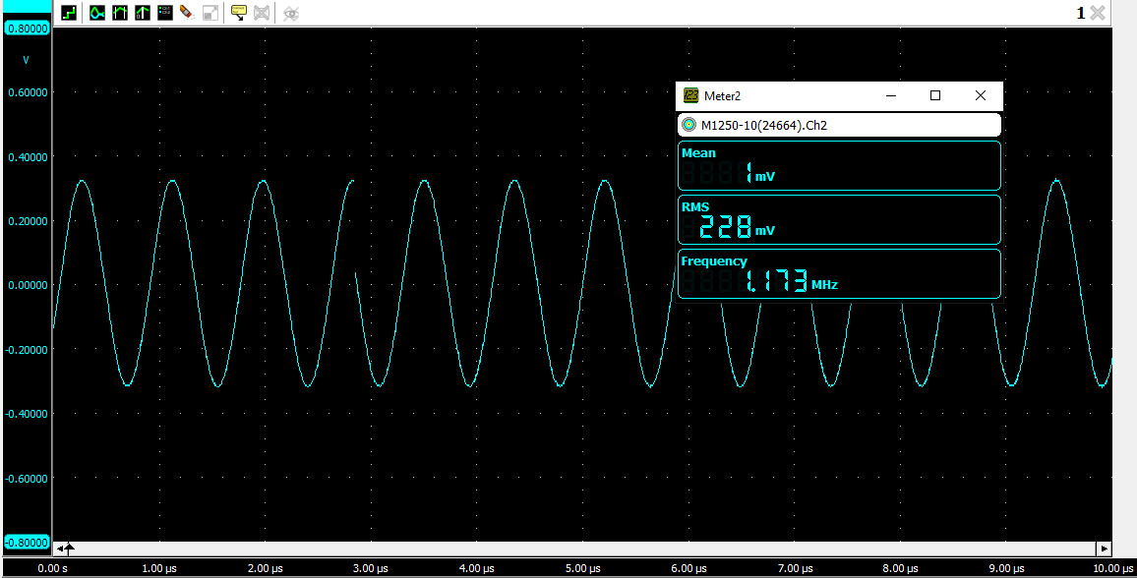

1. Connect the channel 2 probe to the output of the modulator, Trigger on channel 1.

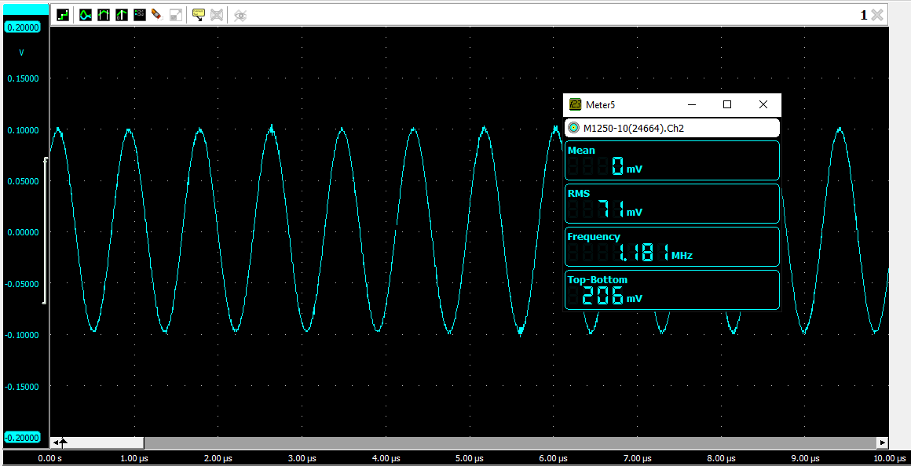

1. Adjust the potentiometer knob so that the AM waveform of oscilloscope channel 2 has 2V between the upper and lower peaks.

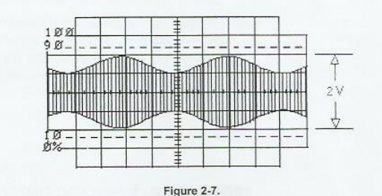

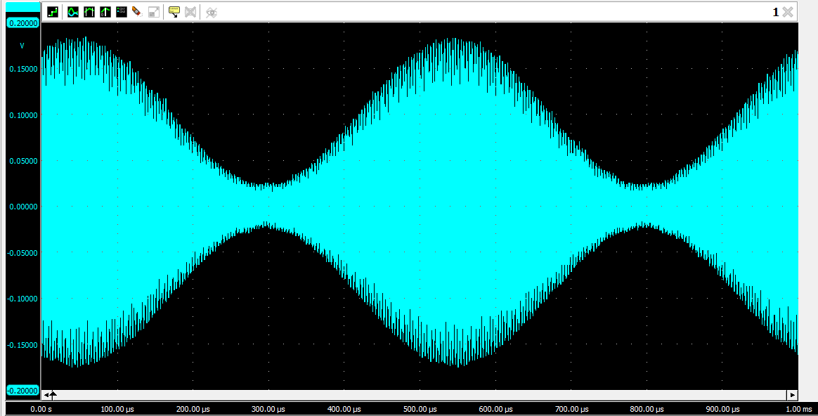

1. Does the AM signal envelope have the same shape and frequency as the message signal.

Yes, the shape of the AM signal is the same as the message signal. However, the frequency of signal has been changed and is according to the frequency of the carrier signal.

1. You have set the carrier signal frequency to 1000Khz and the message signal frequency 2Khz. What frequencies are present in the frequency spectrum of AM signal.

The frequencies present can be observed from the frequency spectrum that has been plotted below. The biggest peak is observed between the frequency interval of 1MHz and 1.5 MHz.

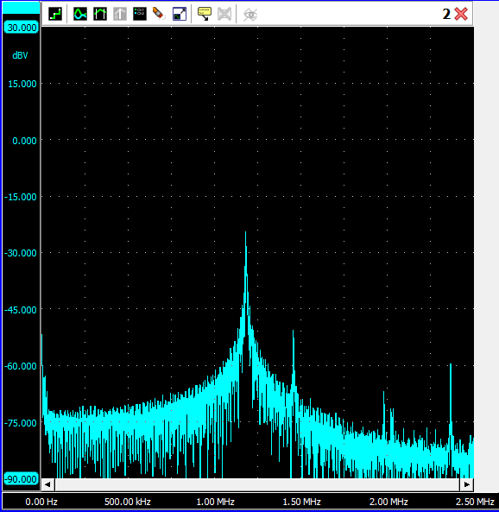

1. Change the signal generate function from a sin wave to square wave. Did envelope of the wave change from a sin wave to square wave.

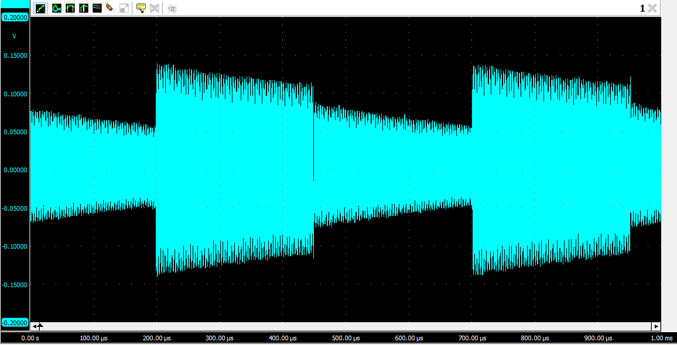

After changing the signal from sine wave to square wave, there was an obvious change in the envelope shape. It also was formed in a square shape.

1. Return the signal generator function to sin wave, while observing the AM output signal on channel 2, vary the signal generator AF frequency knob to vert the message signal frequency. Did frequency of the AM signal envelope change to correspond to the frequency of message signal.

Yes the frequency of the AM signal envelope changed corresponding to the frequency change in the message signal.

1. Readjust the frequency of message signal to 2Khz, while observing the AM output signal, vary the AF level knob of signal generator to vary the amplitude of message signal. Did the AM signal envelope change to correspond to the amplitude of message signal

Yes the envelope changed as per the amplitude of the message signal.

**Modulation Index and Modulation Percentage:**

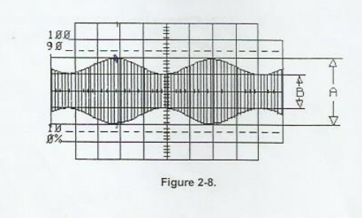

1. Switches S1, S2 and S3 should be off.

1. On oscilloscope channel 1, adjust the peak-to-peak voltage of message signal to 0.2Vpk-pk. If necessary, adjust the modulators potentiometer knob so that AM waveform shown on channel 2 has 2V between upper and lower peaks. 2V is measurement A in figure 2-8.
2. On oscilloscope channel 2, measure the vertical height (in volts) between upper and lower valleys (measurement B in figure 2-8 of modulated waveform.



Vertical Height (in volts) = 0.04 V

1. Calculate the modulation index m.
2. Calculate the percentage of modulation.

% modulation = 78.9%

1. Whie observing the AM signal on channel 2, increase the amplitude of the message signal until the AM signal envelope waveform touches the reference line as in figure 2-11 the difference represented by B on the AM signal waveform is now 0.0V.

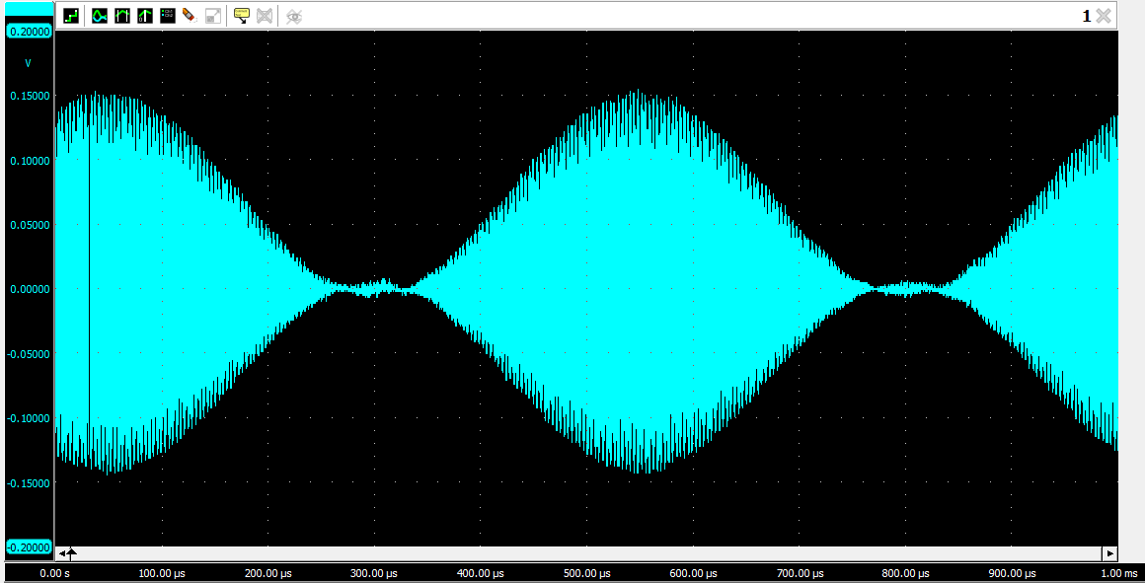

1. On oscilloscope channel 2, measure the vertical distance (in volts) between upper and lower peaks (measurement A in figure 2-11 of modulated waveform.

Vertical Distance (in volts) = 0.30 V

1. Calculate the modulation index m.
2. Calculate the percentage of modulation.

% modulation = 100 %

1. Switches S1, S2. and S3 should be off. Set oscilloscope in the normal mode (out of X and Y). readjust oscilloscope Volt/division and time/division so that signal on channel 2 appears.

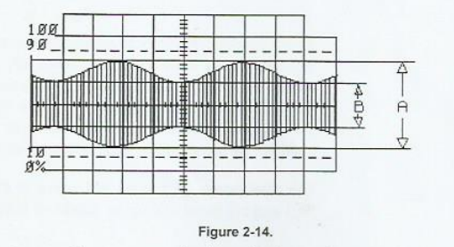

1. Increase the message signal amplitude on channel 1 by adjusting the AF level knob on the signal generator until AM signal as shown appears, it is modulated or over modulated.

28. Is the modulation index of AM signal is greater or less than 1.

The modulation of this modulation which is overmodulation is greater than 1.

29. Is overmodulated signal desirable in AM communications?

No, overmodulated signals are not desirable in amplitude modulation communications, because it clips the peaks of modulated signal that leads to distortion of the original message signal.

30. Reduce the message signal so that AM signal on channel 2 is 100% modulated.

31. Calculate transmission efficiency. (m^2/(2+m^2).

The transmission efficiency for the 100% modulated signal is as follows:

**Calculation of Modulation index from oscilloscope**:



= 1

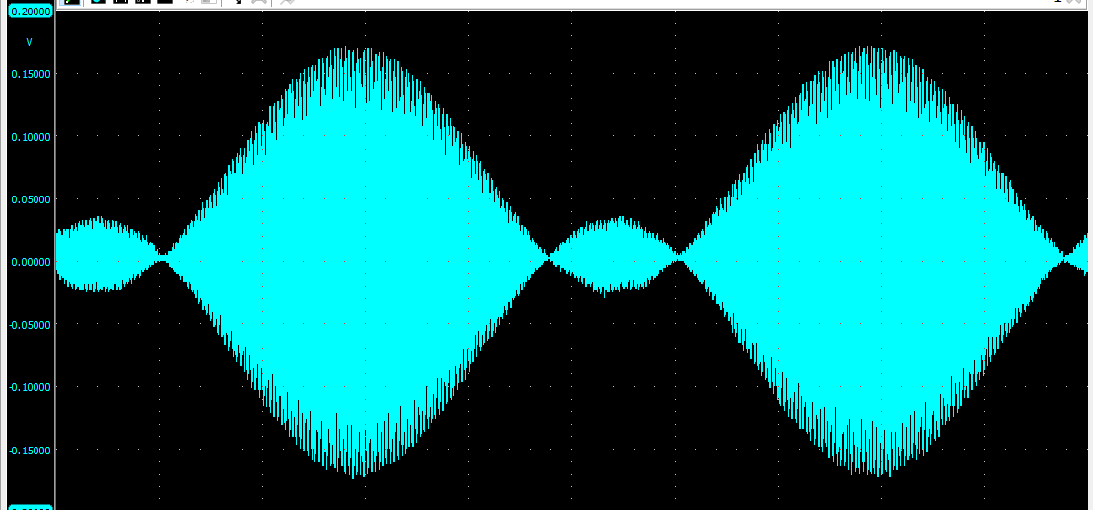

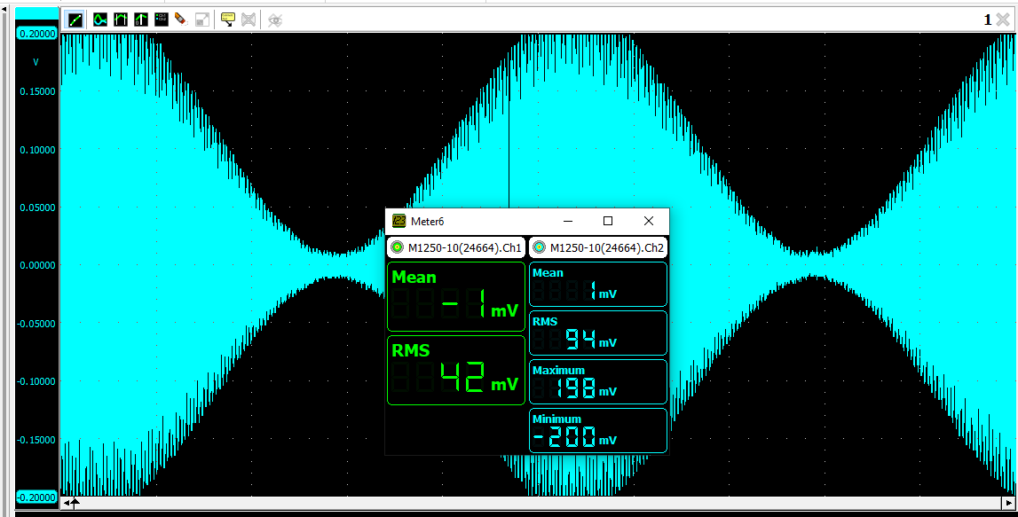

= 0.904

**Conclusion:**

In this lab report on communication systems, we explored the concept of amplitude modulation (AM) and learned about its key characteristics. The modulation index was identified as a crucial parameter in AM signals. We also discovered that overmodulation can lead to distortion of the original message signal and difficulties in demodulation at the receiver. Additionally, we measured the transmission efficiency of AM signals. Finally, we confirmed that the envelope of the AM signal should match the shape of the modulating message signal.